**TECHNICAL COMPUTER CONCEPTS [3rd Quarter]**

TCC: 2:03 pm 01/21/2023

Types of Personal Computers (MicroComputer)

> Smallest computer created

- Desktop:

: most common type of personal computer

: made/design for table/desk

: system you see around in schools, home, and offices

: as of today, desktop computer are more powerful in this generation

- Workstation

> Specialized Personal Computer

> Single user; more powerful, and more features than Standard PC4

> High resolution monitors and graphics

Mostly used by:

: Scientist

: Engineer

: Animators

- Notebook Computer(Laptop)

> More popular but less power than desktop computer

> Smaller size

> Operated by both alternating current and direct current battery

GPU:

Graphics Processing Unit

- Tablet

> Newest development in portable

> Full featured pc

> less performance

- Handheld/Mobile Device

> [PDA] Personal Digital Assistance

> Fits in your hand

> Mostly used by negotiators/corporators/companies

- Smartphone

> most used personal computer

> portable

Network

> connection between devices

Identifying the key parts of computer

Note:

Group Presentation *Reporting*

- 8 members

-

TCC W3 1:28 pm 01/28/2023

Identifying Key Parts of Computer:

> Motherboard:

- Backbone that ties the computer's components together at one spot and allows them to talk to each other

- main hub

: Standard-ATX (Advance Technology eXtended)

- pre-built computer system

: Micro-ATX

: Mini-ITX (Information Technology Extended)

: Nano-ITX

: Pico-ITX

- Smart phones (Handheld computer)

> Parts of Motherboard:

: PCi Express

- for Graphic Card/Video CArd

: Peripheral Component Interconnect

- external soundcard, landcard

; replacement for specific internal parts

: Earphone, Headphone, Audio Port

-

: Display Port:

- VGA, DVI, HDMI

IDE Connector/Cable (outdated) (Integrated Drive Electronics)

SATA Connector/Cable (Serial Advanced Technology Attachment)

: CMOS (Complementary Metal-Oxide SemiConductor)

- battery

: RAM Slot

- limited compatibility

CPU (Central Processing Unit)

- brain of computer system

- a computer hardware that carries out a computer's instructions and controls all the arithmetical, logical, and input/output operations of a computer system

- most important part of computer

- also known as micro processor/ central processor

Location:

- placed in the CPU socket center around the VRM section of the motherboard connected with the other hardware elements inside the computer cabinet

- situated under the Heat Sink to regulate temperature

VRM:

- Voltage Regulator Module

Intel 4004:

- world's first microprocessor invented by intel company

- March, 1971 (November 15)

- 4th generation

Function:

- store and process by performing all the mathematical and logical calculations with the input data to provide the output data to the users, thereby working on the computer

Input Device:

- keyboard

- mouse

- microphone

- scanner

- camera

- sensor

Data Storage: Processes and stores Cache for Future Use

- HDD

- SDD

- Memory Cards

- Pen Drives

- Optical Disks

Output Device:

- monitor

- printer

- speaker

- headphone

- screen projector

- plotter

Cycle:

1. Fetching

- receives basic instructions or series of binary numbers from RAM to CPU

2. Decoding

- data is loaded to CPU and performs logical and arithmetic operations

3. Executing

- decoded instructions will be execute, computer has to carry out the instruction during execution step

- loading and performing data from memory

Importance:

- Accountable for processing data

Brain:

- Manages functions throughout the whole system

Components:

- ALU (Arithmetic Logic Unit)

- CU (Control Unit)

- Registers

- Cache

- Busses

- Clock

Types:

- classified to cores

; single-core

; dual-core

; quad-core

; Hexa-core

; Octa-core

; Deca-core

- classified to architecture

Main Functions:

- Fetching

- Decoding

- Execution

2:26 pm 01/28/2023

Motherboard

-the backbone that ties computer’s components together at one spot and allows them to talk to each other.

Types:

* Standard-ATX
* Micro-ATX
* Mini-ITX(information technology extended)
* Nano-ITX
* Pico-ITX

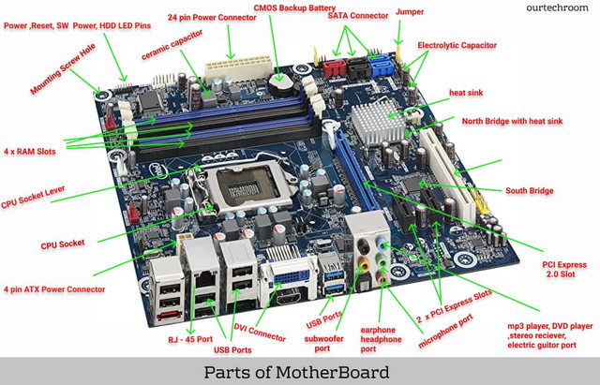

What is CPU?

* CPU or Central Processing Unit that carries out a computer’s instructions and controlls all the arithmetical ligical and input/output operations of a computer system.

1st microprocessor of intel: Intel 4004

Where CPU is located in the computer?

* This CPU is placed on the CPU around socket center around the VRM(Voltage Regulation Module) section of the motherboard connected with other hardware elements inside the **computer cabinet**.

What is the function of CPU in computer?

* The main function of CPU in the computer is to store and process by performing all the mathematical and logical calculations with the input data to provide the output data to the users, thereby working on the computer.

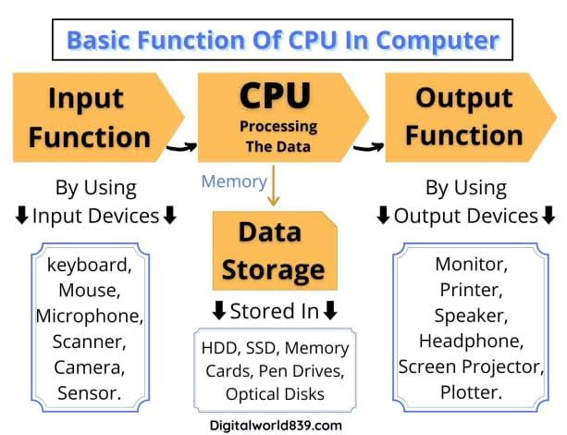

How CPU (Central Processing Unit) works?

1. Fetching
2. Decoding
3. Executing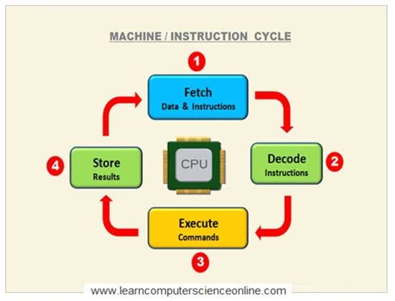

FAQ’s

* Why CPU is important?
* Why is rhe CPU called the brain of the computer?
* What are the components of CPU?

-ALU ,CU , Register, cache,buses, clock

* Types of CPU?

-Single-core, dual-core, quad-core, hexa-core and deca-core.

* What are the 3 main functions of CPU?
* Are CPU and processor the same
* Why CPU is situated under the heat sink?

*COMPUTER CASES/TOWERS*

**CONTINUATION:** Identifying key parts of a Personal Computer

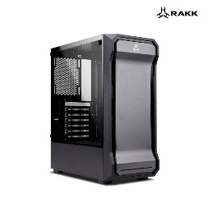

What is PC Case?

* The computer cases are a visible part of our computers called PC towers and Computer towers. Its function is to serve as a protective structure for the rest of the internal components where they will be assembled.

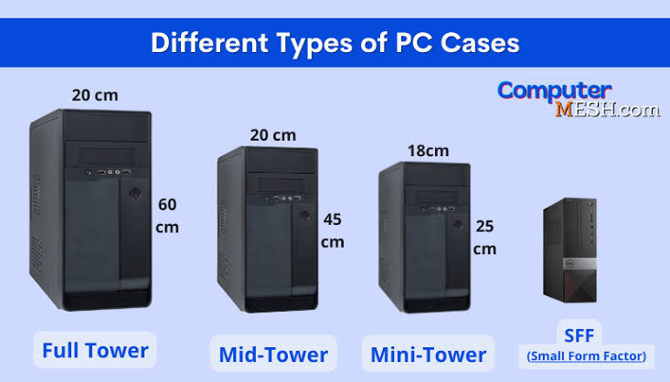**4 Different types of Computer Cases**

**FULL TOWER**

-Full Tower is used to accommodate an **E-ATX** (Extended-Advance Technology eXtended) **or CEB (**Compact Electronics Bay Specification) **motherboard**

* **E-ATX** = 13” instead of 9.6”
* **CEB** = 12” x 10.5”
* Full tower size 55-75cm tall and 22-32cm width

**MID TOWER**

-the most popular and widely used computer case that allows you to use many drives and almost all types of motherboards with acceptable overall dimensions in it.

* Mid tower size 35-55cm tall and 15-25cm width

**MINI TOWER**

-designed to take up as little physical space and without Installing decent-sized graphics cards

* Mini tower size 30-45cm tall and 15-25cm in width

**SFF (SMALL FORM FACTOR)**

-These types of cases were considered very niche, but in recent years they have gained popularity due to the miniaturization of powerful components that can fit in them.

**Power on Self Test**

***What is POST (Power on Self Test) in computers?***

The Power On Self Test, or POST, is a diagnostic procedure that a computer performs when it boots up and is stored in the ROM BIOS on the motherboard.

Using POST to recognize failures

* + Beeps sound
  + Messages displayed on the monitor screen
  + Hexadecimal error codes issued on the / O port

**Tests of *Power on Self Test***

* CPU register test,
* ROM checksum test,
* System timer and beeper port test,
* Checking the DMA controller,
* Reviewing the lower region of RAM for projecting resident programs in the BIOS,
* Launch of local programs,
* Checking the standard graphics adapter (VGA),
* Testing RAM,
* Checking the main input devices,
* CMOS check,
* Checking the main LPT / COM ports,
* Checking hard disk drives (HDD), and SSDs,
* Self-testing of BIOS functional subsystems,
* Transferring control to the bootloader.

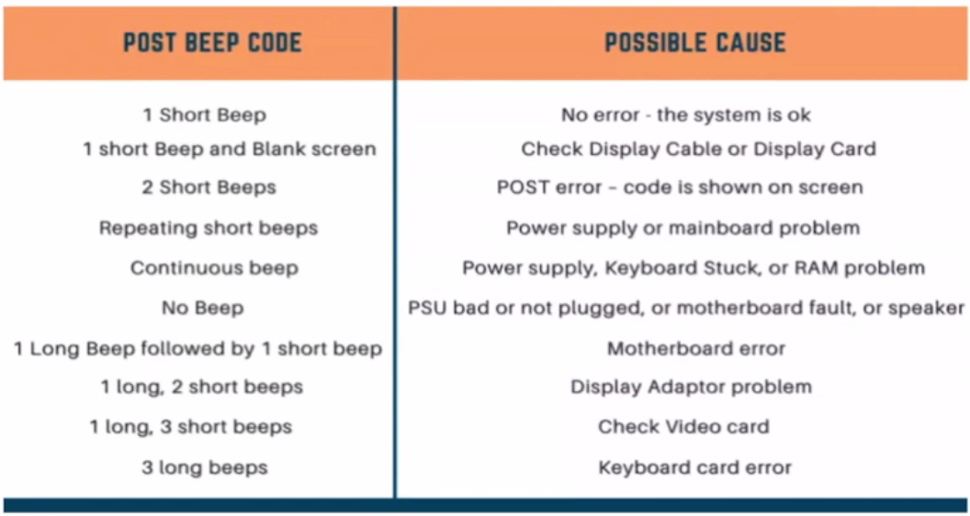

|  |  |
| --- | --- |
| POST BEEP CODE | POSSIBLE CAUSE |
| 1 Short Beep | **No error - the system is ok** |
| 1 Short Beep and Blank screen | **Check Display Cable or Display Card** |
| 2 Short Beeps | **POST error - code is shown on screen** |
| Repeating short beeps | **Power supply or mainboard problem** |
| Continuous beep | **Power supply. Keyboard Stuck. or RAM problem** |
| No Beep | **PSU bad or not plugged. or motherboard fault. or speaker** |
| 1 Long Beep followed by 1 short beep | **Motherboard error** |
| 1 long 2 short beeps | **Display Adaptor problem** |
| 1 long. 3 short beeps | **Check Video card** |
| 3 long beeps | **Keyboard card error** |

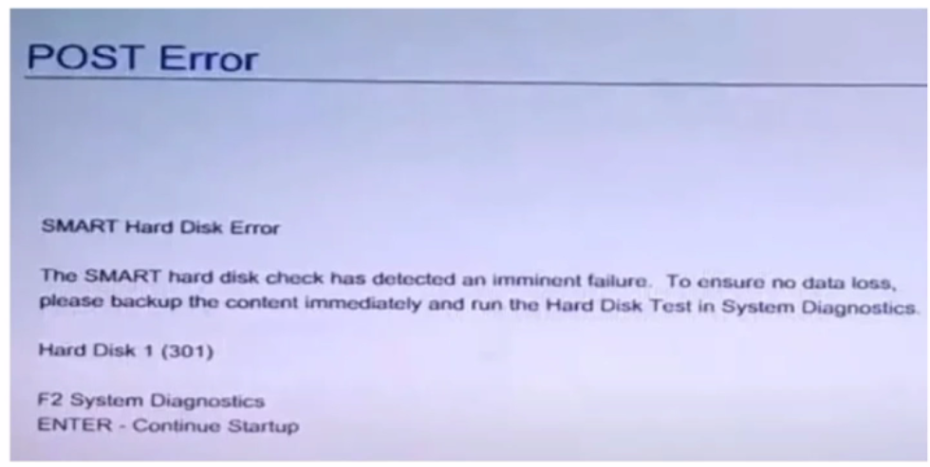

|  |  |
| --- | --- |
| Error Code | Possible Cause |
| 301 | Indicates the hard drive is failing |
| 201 or 203 | Memory module failure detected |
| 1101 | Malfunction in your system operation or failed installation of software, or **system crashing** |
| 601 | Battery error or dead |
| 161 | Irregular entries in the Windows registry or in configured system |

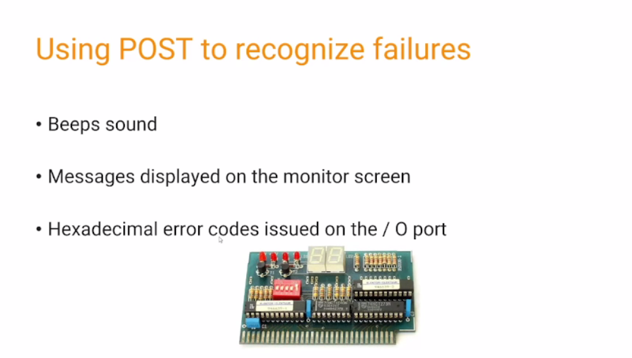

Expansion slot

3 basis post card made

* **ISA slot** > x86 architecture
* **PCI slot** > x86 architecture (power CPUs)
* **AGP slot** > x86 architecture

Standard steps to resolve errors if you are getting some sort of error in the post code you can try suggestions and look at if they solved the issue

* Restart
* Unplug any drives or USB devices.
* Disconnect external devices.
* Reconnect the power supply cables.
* Identify the beep code using the component or device manual.
* Check the fans turned off or on.
* Disconnect all expansion cards.
* Power off and on the computer.
* Check if the BIOS chip is loose.
* Update BIOS.
* Change motherboard, GPU, RAM, PSU, storage disks as a proxy to see whether the POST continues to proceed further.

**TECHNICAL COMPUTER CONCEPTS [4th Quarter]**

**PRIMARY MEMORY IN COMPUTER**

Storing the data, instructions, and information on the computer is called **memory**.

**What is the primary memory of a computer?**

* **Memory** is a very essential component present on all [computer cases](https://digitalworld839.com/what-is-primary-memory-of-computer-examples/digitalworld839.com/casetype/), without it the computer cannot complete even a simple task.
* Computer memory is mainly divided into two types: **primary and secondary memory.**

**Primary Memory**

* Processes the data and instructions while the computer unit is being processed. Primary memory stores the data or instructions for quick access. **Semiconductor chips** are the main component used in primary memory.
* Is known as the main memory or temporary memory on the computer.
* The main purpose of primary memory is to store frequently used programs that can be directly accessed by the [processor](https://digitalworld839.com/types-of-central-processing-unit/) for further processing. It is volatile memory, meaning that data is stored temporarily and can be lost when the power is switched off.
* This memory is present in the [CPU of the computer](https://digitalworld839.com/what-is-the-function-of-cpu-and-how-cpu-works/), from where the device receives the data and instructions. RAM and ROM are examples of the Primary Memory of computers.

#### What are primary memory’s characteristics?

* The primary memory of a computer is also called main memory, temporary memory, or prime memory.
* It is a volatile memory.
* This memory is made of semiconductors technology.
* Data is automatically deleted in the event of power failure.
* The processing speed is faster than secondary memory.
* This is the main working memory of the computer.
* A computer is not able to process without primary memory.

**Examples of Primary Memory**

Examples of primary memory are divided into two types:

**1. RAM**

RAM stands for ‘Random Access Memory‘. RAM is a primary memory example that stores operating system software, software applications, instructions, and other information for (CPU) the central processing unit for direct and quick access when needed to perform tasks.

RAM is one of the fastest types of memory, and it has the ability to read and write the data, but as long as there is Power Supply to the device. When the computer is off, all the processed data of RAM automatically goes to the trash.

The RAM is mainly used for running software, playing games, and media like audio and videos.

#### **Characteristics of RAM:**

* RAM is volatile memory i.e temporary memory.
* The storage of RAM is usually low as compared to secondary memory.
* RAM is much faster and expensive than Secondary Memory.
* All programs, Applications, Games, Graphics, and Instruction processes through RAM Memory.
* RAM memory is an important component of the CPU.

**Examples of primary memory’s RAM Further has in two Types:**

1. DRAM: Dynamic Random Access Memory
2. SRAM: Static Random Access Memory

While a **DRAM** module only requires **one (1) transistor and one (1) capacitor** to store every bit of data, **SRAM** needs **6 transistors.** Since the number of transistors in a memory module determines its capacity, for a similar number of transistors, a DRAM module can have up to 6 times more capacity than an SRAM module.

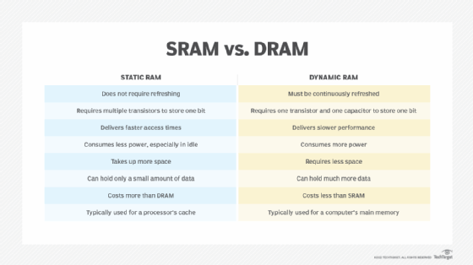

**2. ROM**

The full form of ROM is “Read Only Memory“. This is permanent memory in which information is entered into it once and stored permanently (even the computer turned on and off).

The stored programs and data cannot be modified and deleted in this memory, they can only be read. Therefore this memory is called read-only memory. Even after the computer is turned off, the stored data in the ROM doesn’t destroy it. Thus, ROM is called non-volatile or permanent memory.

ROM memory is used in all types of electronic devices such as Calculator, Smartphone, Video Game, Digital Camera, etc. Most personal computers need to have high ROM memory for storage.

**Characteristics of ROM:**

* ROM is a permanent memory.
* It stores all the basic functionality instructions of the computer.
* In terms of price, ROMs are cheaper than RAM.
* ROM not only uses less energy but is also very reliable.
* It is used in embedded systems or where there is no need to change any programming.
* They are mainly used in calculators and [peripheral devices](https://digitalworld839.com/peripheral-devices-examples/).

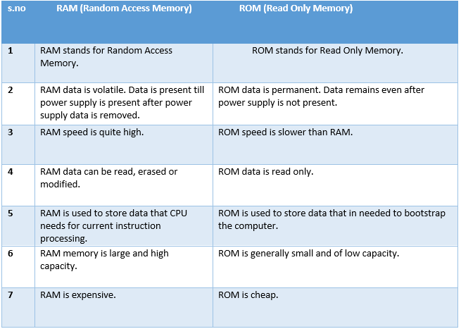

**Examples of primary memory’s ROM further has four types:**

1. MROM: Masked
2. PROM: Programmable
3. EPROM: Erasable Programmable
4. EEPROM: Electrically Erasable Programmable

**Difference Between Primary and Secondary Memory**

Computer memory is classified into two primary and secondary. The primary memory of a computer is the main memory that is used to store data or information temporarily, while secondary memory refers to secondary storage devices that are used to store data or information permanently.

**7 Most Common Symptoms to tell if you have a bad RAM**

1. Drop in Computing Performance
2. Automatic / Unauthorized reboot
3. Random Application Crashes
4. Data and Files get corrupted
5. BSOD flashes once in a while
6. Video Card fails to load
7. Computer beep sound during POST.

**What causes RAM failure?**

1. Manufacturer fault
2. Power surges or excessive heating
3. Voltage and Timing failure due to overclocking
4. Faulty connector
5. Age

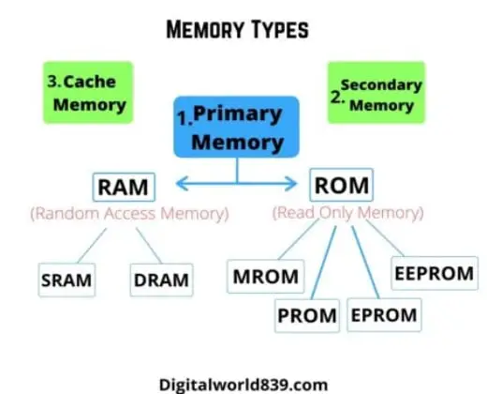

|  |  |  |
| --- | --- | --- |
| **Differences** | **Primary Memory** | **Secondary Memory** |
| **1. Nature** | Primary Memory is Non-Volatile i.e. After shutting down the power the data automatically gets deleted. Thus, Primary Memory used to store the information temporarily. | Secondary Memory is Volatile i.e. Even after shutting down the power the data saved doesn't get deleted. Thus, Secondary Memory stores the information permanently. |
| **2. Other Names** | It is also known as Main, Temporary and Internal Memory. | It is also known as Permanent and External Memory. |
| **3. Accessing Speed** | Data processing speed is faster than Secondary memory. | Data processing speed is slower than primary memory. |
| **4. Transferable** | Information stored in Primary devices cannot be moved from one place to another. | Information stored in Secondary memory can be easily transferred from one computer to another. |
| **5. Made** | Primary Memory is made of semiconductors technology. | Secondary Memory is made up of magnetic and optical devices. |
| **6. Size** | The primary memory of the computer is mainly available in small sizes starting from 500MB up to 32GB. | These memories are mainly available in larger sizes than the primary memory up to or more than 1TB. |
| **7. Cost** | Primary memory is more expensive than secondary one. | Secondary memory is cheaper than primary memory. |
| **8. Examples** | Examples of primary memory include RAM and ROM. | It includes a Hard Disk drive, [SSD connectors](https://digitalworld839.com/types-of-solid-state-drives-and-connector-type), Optical Disk, USB Drive, Memory Cards, etc. |

**Frequently Asked Questions**

1. What are types of primary memory?

*There are two types of primary memory: RAM and ROM. RAM stands for ‘Random Access Memory’. which processes operating system software, software applications, and other information for the central processing unit quick access when needed to perform tasks temporarily. While ROM ‘Read Only Memory’ is Permanent memory in which information is entered into it once and stored permanently which can be modified further.*

2. Which is faster, primary or secondary memory?

*The data processing speed of primary memory is faster than Secondary memory. Also, primary Memory is made of semiconductors technology.*

3. Why is RAM and ROM called primary memory?

*The primary memory is divided into RAM and ROM. RAM has the ability to read and write the data, as long as there is Power Supply to the device. When the computer is switched off, all the processed data of RAM automatically goes to the trash. While ROM is Permanent memory in which information is entered into it once and stored permanently (even the computer turned on and off).*

4. Which is primary memory RAM or ROM?

*Both are examples of Primary Memory. All programs, Applications, Games, Graphics, and Instruction are processed through RAM Memory. ROM memory is used in all types of electronic devices such as Calculator, Smartphone, Video Game, Digital Camera, etc.*

5. Where is primary memory stored?

*Primary Memory is stored in the computer The main purpose of primary memory is to store frequently used programs that can be directly accessed by the processor for further processing. It is volatile memory, meaning that data is stored temporarily and can be lost when the power is switched off.*

6. What are the alternative names of a primary memory?

*The alternative name of primary memory is the Main Memory and Internal Memory of the computer.*

7. What is the size of the primary memory of the computer?

*The primary memory of a computer is mainly available in small sizes starting from 500MB up to 32GB.*

# 

# 

**WHAT IS A MODULAR POWER SUPPLY? (SEMI, FULL AND NON MODULAR)**

**What is a Modular Power Supply?**

* A modular power supply is an electronic device, inbuilt cable with few attached or fully detached presents in a PC case, responsible for supplying electrical energy to essential PC elements like motherboard, processor, HDD, SDD, [cooling fans](https://digitalworld839.com/computer-case-fan-sizes/), etc., through a connecting a power supply [slot available on the motherboard](https://digitalworld839.com/motherboard-slots-types).

In other words, it distributes the voltage power throughout the computer system. It usually looks like a metal box, located in the corner or bottom of the computer case.

There are two types of modular power supply:

1. **Semi Modular Power Supply.**
2. **Full Modular Power Supply.**

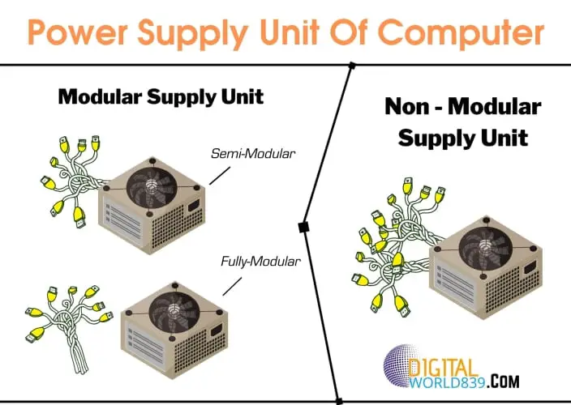

**Semi Modular Power Supply**

The semi-modular power supply is those units in which the built-in wire cables are for the connection of only the main components of the computer such as [motherboard](https://digitalworld839.com/what-is-a-motherboard/), processor, and video card.

Along with dedicated cables, SATA cables, and sometimes an additional PCIe cable are modular options. Here, the cables are limited and attached permanently to the body of the power supply, not so the rest of the cables.

The semi-modular power supply has both detachable and non-detachable cables. This means that you can attach cables separately that can be connected or disconnected as necessary to mount the equipment or not, as per your additional requirements for the other [units of the computer](https://digitalworld839.com/parts-of-computer-pictures/).

While the ATX and [CPU](https://digitalworld839.com/types-of-central-processing-unit/), mandatory in all equipment, they cannot be disconnected. Semi modular power supplies have main cables such as 24-pin, 8-pin, and PCIe cables, all connected to the same board. The photo of the semi modular supply is given below.

###### Advantages of Semi-Modular Supply:

1. The advantages of such a PSU are that the remaining cables are connected through individual connectors in the unit, only which is significantly required for the PC.

2. This helps keep the number of cables inside the PC case as small as possible, as well as leading the source’s performance over the rails that are connected.

3. The semi-modular sources generally bring necessary fixed cables such as (ATX + CPU), and sometimes others very used like the [PCIe cables](https://allpinouts.org/pinouts/connectors/power_supply/pci-express-pcie-6pin-power/).

4. A semi-modular power supply is a great way to save money for the new PC. You don’t have to compromise too much with unused cables as you will connect the majority of the significant pre-wired cables.

###### Disadvantages of Semi-Modular Supply:

The semi-modular power supply is a little bit high in price compared with non-modular PSU.

**2. Full Modular Power Supply**

All the cables in the case of a fully modular power supply are disconnected. The fact is that there are simply no cables built into the fully modular unit since they are supplied separately.

There are needed cables additionally for the modular power supply to plug each wire into its own [socket](https://en.wikipedia.org/wiki/AC_power_plugs_and_sockets), thereby supplying the power to all either standard or essential computer components. This means you can connect and disconnect any [computer](https://digitalworld839.com/types-of-microcomputer-with-pictures/) unit whenever necessary.

The presence of such a unit will allow you to install it even in a miniATX case without losing space in the system unit. This indicator is justified by the fact that manufacturers create such blocks, placing only the necessary “stuffing” inside and of excellent quality.

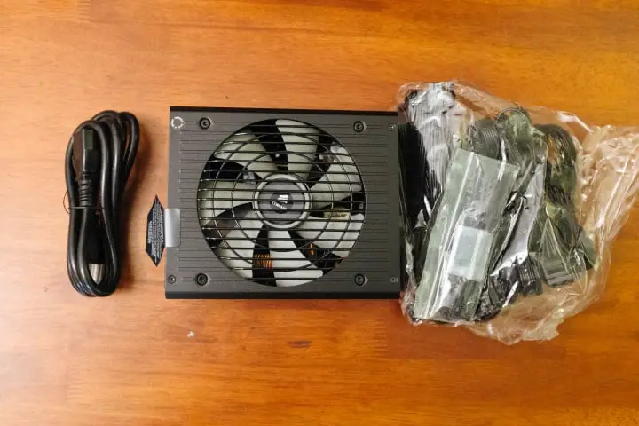

###### Advantages of Full Modular Supply

The advantages are the same as the Semi-Modular Supply. Also, there are no cables built-in which gives you more choice and freedom to make use of any device or component for the connection.

###### Disadvantages of Full Modular Supply

Typically, the cost of a modular power supply for a PC’s [motherboard is more expensive](https://digitalworld839.com/why-are-motherboards-so-expensive/) than the price of a regular one. This is the biggest drawback of a full modular PSU.

**What is a Non Modular Power Supply?**

Non-modular power supplies look and work the same as other modular power supplies. Still, the main difference is that in modular power supply units have few cables attached or fully detached cables while in non modular power supply all cables are soldered.

They are widely used even in [server systems](https://digitalworld839.com/types-of-servers/). The cables are fixed to the internal circuit of the source, and they exit through a small hole in the back to be mounted on a computer, since its fixed means that all cables are integrated into it and cannot be removed as we show you in the image.

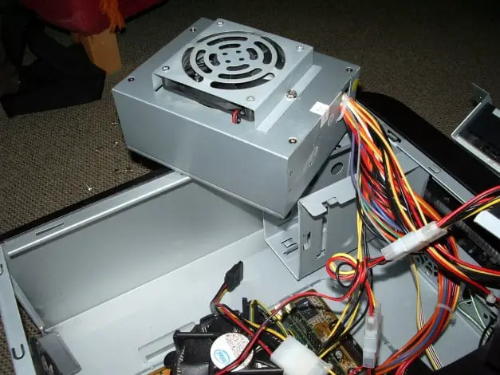

###### Advantages of Non Modular Power Supply

Non-modular power supplies are the most common units used as stationary computers, office equipment, and even specialized gaming ones.

Non-modular PSUs are often used in budget builds, and they can still power your system efficiently.

If you are on a tight budget or are building a system in a windowless chassis, then a non modular power supply is acceptable.

Non-modular power supplies are cheaper than modular power supplies.

###### Disadvantages of Non Modular Power Supply

Due to a lot of wires, you need to have good cable management to maintain good airflow unless it can damage the internal equipment of the cabinet due to overheating.

Also, the lack of cable management can create a bad appearance on your computer.

By having all the cables fixed in the source and you are not being able to remove any inessential cable since they are tightly soldered inside.

Also, you can find that you are not going to use them all, and therefore the cable is covered with dust, which is quite annoying.

Excess wires will interfere with average air circulation, which can lead to [heating of the equipment](https://digitalworld839.com/what-happens-when-computer-overheats/), this, of course, affects the cooling system.

#### Conclusion:

All the significant points that impact the modularity of power supplies have been explained above. Anyway, Power Supplies are continually being upgraded, and according to their connection methods, it is time to give the final recommendation.

In those scenarios where you are trying to save pennies to get the best processor or graphics card, it makes sense to opt for a budget non-modular PSU. A semi modular PSU is also a fine choice, but if you have a large budget, go for a fully modular PSU.

#### 

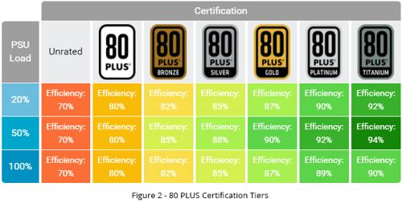

#### 

#### **Frequently Asked Questions**

#### 1. What does it mean when a power supply is modular?

#### *Either partly cables attached to the supply unit for connection or fully detached cables and connections through separate wires via socket. Such cables availability of PSU is called a modular power supply.*

##### 2. What is the difference between a modular and non-modular power supply?

*The main difference is that; modular power supply units have either few cables attached or fully detached cables, while in non-modular power supply, all wires are soldered.*

##### 3. What do you do with the wires that you don't need in a non-modular power supply?

*If there is no use of some writes in the PSU, you can cover or protect them with a cap to prevent short circuits and fold them far removed.*

##### 4. What is the advantage of a modular power supply?

*The best advantage of a modular power supply is you can configure the cables as per your need and like and the modular power supply enhances the appearance and airflow of the computer case.*

##### 5. Do modular power supplies come with cables?

*Only semi-modular power supplies come with cables, while fully modular power supplies don’t come with cables. In this case, you need to buy separate cables for the connection.*

**POWER OUTAGE**

**What is a Power Outage And A Power Surge?**

The scenario (lights flickering and then electricity going out) shows 3 main types of electricity anomalies:

1. The most obvious one is the power outage, also known as a blackout. A **blackout** occurs when the power is completely cut off. It happens for several reasons, including power station disruptions, damaged electrical lines, load-shedding, or self-inflicted damage – such as short-circuiting.

Lights flickering 2 possible reasons:

* Not enough power available, causing a brownout
* A **power surge** occurs when an excessive amount of electricity comes from the socket source.

**How Do Power Outages or Power Surges Damage Your PC Components?**

There’s a reason our PCs have the shutdown option. They are designed to go through a series of processes before turning off. Therefore, a direct power outage or a power surge can be damaging in some circumstances, and in others, they will leave your system unscathed.

**1. Effect On PSU – The Self Sacrificial Heroes**

* In a situation where your PC faces an electrical anomaly, your PSU will offer the first line of defense. It will cover the unit and cut off the power supply to prevent damage.
* In the worst-case scenario, you’ll hear a loud band, and the PSU will self-destruct first, preventing

damage from spreading to the rest of the system. This also happens when a PSU lifespan is nearing the end.

* If your computer won’t turn on after the PSU has caused a power outage, there is still hope. You can remove the power supply’s “dirty power” by leaving the system off for several hours (or a few days, to be sure). Meanwhile, you may test another PSU to ensure your PC is safe.

Note – There is one condition that must be met in order for the PSU to fulfill its potential as a savior. A good PSU from reputable manufacturers should be used. That is why installing cheaper power supply units, either modular or non modular is never suggested.

**2. Effect on System Files**

* This is probably the nastiest effect of a sudden shutdown. Although it doesn’t cause hardware damage, so you don’t have to worry about replacement costs, it can cost you in terms of hours. And if it were billable hours, well, then it does cost you moneywise.

For example, suppose the power goes out during normal usage. In that case, you will most likely be greeted with the familiar disk check screen when you power on or restart the PC, which is good.

**3. Effects on Storage Devices**

*Hard Disk Drives (HDD)*

* HDDs suffer from sudden power outages and face a reduced life expectancy. The reason is that a sudden power cut brings the spinning disc to an abrupt and uncontrolled stop. Furthermore, the reading and writing head (which hovers over the spinning platters) has to quickly snap back into place.
* This snapping makes it susceptible to a “head crash,” which occurs when the head touches the platter surface, scraping the area. The scrapped part can no longer record data, leading to crashes and slowdowns, eventually declining the HDD durability.

*Solid State Drives (SSD)*

* The result of power outages on SSDs is difficult to generalize. It might be affected or not. As compared to HDDs, older SSDs were much more vulnerable, and the impact ranged from data corruption to system failure.
* Fortunately, manufacturers have realized this issue and introduced a new safety feature called **PLP (Power Loss Protection) Mechanism**.
* PLP protects the data in the buffer from complete loss, as SSD does not have enough time to complete its tasks in case of unexpected shutdowns. This is accomplished with the help of capacitors on the SSDs that provide just enough time for the data to be flushed to long storage.
* However, SSDs have a limited life span. When they reach the end of their useful lives, SSDs are reset to zero regarding data loss or corruption. As a result, an outage may or may not cause SSDs to deteriorate.

*Primary Memory – RAM*

* RAMs aren’t affected due to power outages or surges. It is because multiple components will be affected before the RAM gets its turn. First, the PSU will die, then the motherboard (that too in some infrequent instances), and then the primary memory – RAM.
* If RAMs memory life is damaged, they usually include a lifetime manufacturer’s warranty. So, you can just claim its warranty and get a replacement.

**What Are the Symptoms of a Computer Power Surge?**

* Your PC isn’t turning on,
* You are facing trouble while booting up your system (stuck in a boot loop and reboots spontaneously),
* The fans are making a strange noise or are spinning very fast,
* PC is suspiciously overheating,
* You get electrical shocks when you touch the computer case,
* The PSU is failing and isn’t working at all.

The surge protectors limit the voltage beyond a set limit. And if the voltage exceeds the capacity, they burn themselves out, breaking the circuit between the wall socket and the PC.

**Why Should You Get A UPS?**

Surge protectors do protect your PC in case of power surges, but they don’t do much in a sudden shutdown. This is where UPS can help and is always recommended with a PC.

The UPS isn’t meant to keep your PC on the entire duration of a power outage, but they serve several important purposes. They supply battery backup for a few crucial minutes for you to save your work and safely shut down the system.

In addition, it serves as a two-in-one device by also acting as a surge protector. The UPS’ list of functions does not end there. It also serves the purpose of supplying clean and evened-out power, so you don’t face the small (unhealthy) drops in power when you turn on the AC.

The best part? The UPSs are totally worth it since they are going to be protecting a system that is worth 5x, maybe even 10 times their cost.

Power outages and power surges both are harmful to your computer. However, it is the power surges you need to really worry about.

They can cause problems ranging from suspicious behavior of your computer to a complete loss of a component. Likewise, a power outage can cause nasty problems such as loss of data or data corruption, setting you back on hours of work. In some cases, a reinstall of windows might also be required.

Modern hardware and software, thankfully, are built with some concern for power outages and voltage spikes in mind. Repeated exposure, however, will undoubtedly damage it in some form.

Because of this, it is always recommended to have a computer UPS or, at the very least, a surge protector. They are less expensive than you may think, especially considering the crucial purpose they serve.

It’s possible that an electrical problem will leave your PC unharmed. The risk of pushing your luck, however, is not worth it. Specifically when considering there is some damage in the long-term

# **Frequently Asked Questions**

# 1. Will power outages/surges affect the computer’s performance? Not completely killing the component but making it slow or inefficient?

# *Electrical anomalies may or might damage a computer. However, repeated exposure will certainly damage it. If a component is not entirely fried out, it’s possible you haven’t faced the full force of the issue yet. It may have partially affected something, and the surest way to find out is to keep using the system.*

# 

# 2. Should you get a surge protector or UPS, or both?

# *Getting a UPS for your digital computer is always recommended since they provide protection to appliances 5x-10x their cost price. They also act as a surge protector and can supply clean power to the system. However, if you still don’t want a UPS, a surge protector must be installed.*

# 

# 3. Do computer power supplies have surge protection?

# *No, PSUs generally don’t have built-in surge protection, but they provide some form of protection from power surges. They will limit the excess current to some extent and shut down the system to control the damage. In the worst case, it will die out first and stop the damage.*

# 

# 4. Does a laptop need surge protection?

# *Surge protection is always recommended for any electrical appliance since surge protectors cost next to nothing. Laptops generally don’t need surge protection since; usually, the adapter in their charger would burn out first and cut the current flow. However, you will lose your (more expensive) charger.*

# 

# 

# 

# 

# 

# 

**DIFFERENT MOTHERBOARD FORM FACTORS**

### **( UNEDITED )**

### **What Is A Motherboard Form Factor?**

To put it in simple words, a Motherboard form factor indicates its shape, style, dimensions, and features.

When choosing a motherboard, the size of the Motherboard is a crucial concern as it will, in turn, decide the base power of your build. It can set a limit for you regarding the [type of PC casing](https://digitalworld839.com/different-sizes-of-motherboard-form-factors/digitalworld839.com/casetype/) you use, the number of RAM slots, expansion slots, PCI and PCIe slots, and much more.

**For example**, the older models had DDR3 RAM slots, which cannot support the newer DDR4 or DDR5 models. In addition to the [type of CPU socket](https://digitalworld839.com/different-sizes-of-motherboard-form-factors/digitalworld839.com/cpusock/), are the reasons that can force inexperienced builders (like a younger myself) to rebuild a PC build within a year.

This error is also understandable since there were more than 40 different form factors since the [five generations of computers](https://digitalworld839.com/generations-of-computer-first-to-fifth/). They come from many manufacturers, including ASUS, Intel, and IBM – the first to build Motherboards with their XT build back in 1983. Thankfully, these are now reduced to mostly 3 popular form factors for motherboards.

## **Why Are There Different Motherboard Form Factors?**

The Motherboards have been coming out since the 1980s, and each upgrade was aimed at solving different problems in technology. Where the previous generation would have poor airflow, it would be solved by a newer model.

Similarly, different form factors were developed to solve problems such as size, power requirements, and even noise solutions. Where the ATX Motherboard had a larger size, a need for more compact systems led to the development of smaller ITX boards.

The change in form factor might be a slow process, but with improving technologies, also modifying colors for aesthetics from [green Circuit Boards](https://digitalworld839.com/why-are-circuit-boards-green-facts-reasons/) to gray, blue, red, white colored ones.

Motherboards evolve accordingly, for example, the development of PCI Express (PCIe) technology changed the layout as well as the design of motherboards to incorporate it effectively.

A form factor also provides the necessary details that help identify its users, depending on their requirements. A gamer would want more features such as extra RAM slots. case fans, [ethernet with gigabit support](https://digitalworld839.com/how-to-check-if-i-have-gigabit-ethernet/), or an additional [PCIe NVMe](https://digitalworld839.com/difference-between-nvme-vs-pcie-ssd-explained/) expansion slot and a M.2 slot for more [SSD connectors](https://digitalworld839.com/types-of-solid-state-drives-and-connector-type).

On the other hand, a multimedia system would need to be cooler and quieter while also fitting inside tighter spaces (such as TV cabinets).

### The Earlier Motherboards Form Factors – AT and Baby AT

The ATX Motherboards you see well-known today are the newer versions of the original AT motherboards designed by IBM (also designed the first [XT motherboards](https://en.wikipedia.org/wiki/IBM_Personal_Computer_XT)) and were common in PC builds back in the 1980s. It also went full-AT because of their greater size – 12 x 38 inches, appearing in Pentium P5 to Pentium 2.

However, it had a problem of enormous size that meant they couldn’t fit inside mini-desktop PCs. Hence, Baby AT boards were developed – “baby” referring to their smaller size of 8.5×13 inches.

The Baby AT design was slightly better than their AT counterparts, providing more room for components inside the case. In addition, the connectors and drives inside the cases could fit appropriately with fewer interferences.

These AT and Baby AT Motherboards retired in 1995 by being replaced with the ATX Motherboards because of their **versatility** and **flexibility**. So, let’s know about the three most popular ATX motherboard form factors used today.

## 3 Most popular Motherboard form factors

### 1. **Form Factor Standard ATX**

This form factor is one of the most used today, especially in full and mid-tower PCs. It came out in the mid-1990s and was considered revolutionary at the time because it:

* Replaced the need for riser cards with integrated expansion [type of slots](https://digitalworld839.com/motherboard-slots-types) (riser cards need to be plugged into a motherboard in order to add more functionality),
* Introduced power pins such as the 20-pin connector,
* Introduced serial port and eliminated onboard PS/2 keyboard connector
* Had better air ventilation – because of eliminated need for riser cards that block airflow,
* Lesser interference between drive bays and connectors (as compared to the predecessors),
* Internal I/O connections were now soldered onto the board.

ATX stands for ‘Advanced Technology eXtended’, inherent to its characteristics, and has standard dimensions of 30.5 x 24.2 cm or 12 x 9.6 inches. It is worth building for high-performance professional PCs, office computers, and gaming ones as it accompanies all the necessary functionality and a full-fledged complete base.

ATX boards usually have 7 expansion slots, and for a PSU is suitable to power and house such a system or have enough money for it. A number of expansion slots allow you to install Bluetooth adapters, good sound cards, Wifi adapters, USB hubs, and much other additional equipment that expands your PC’s capabilities.

The ATX form factor is best suited for PC upgrades, too, you can organize high-quality cooling, and there is a wide choice of different cases for this standard.

All these are possible due to their larger size compared to the motherboards down the list. In some cases, the larger size can prove to be a double-edged sword. For example, the larger Motherboard would require an equally larger case. Therefore, it requires a ginormous dedicated space for the gaming rig.

*And what if it’s not to be used as a gaming rig?*

Well, in that case (no pun intended), you would have a ridiculous overkill on your hand. Would you really need multiple [M.2 slots](https://digitalworld839.com/different-sizes-of-motherboard-form-factors/digitalworld839.com/m2/), or multi-GPU support, if you only plan to use your PC for nominal use purposes?

#### Pros and Cons of **ATX** Form Factor

* Wide variability in assembling PCs of various capacities
* Has a full set of I/O connectors
* Have sound airflow
* Have additional expansion slots, like PCIe, SATA, and RAM.
* More and Faster ports
* High quality capacitors and chokes
* Have multiple power headers to connect several air-cooled or water coolers
* Support for [overclocking](https://digitalworld839.com/pros-and-cons-of-overclocking-gpu-cpu/), SLI, or CrossFire
* Not budget-friendly, especially in overkill circumstances
* Compatible only with cases of system units of the same ATX standard
* Doesn’t fit in compact cases except for mid and full tower chassis.
* [Expensive motherboard](https://digitalworld839.com/why-are-motherboards-so-expensive/) than mATX and mini-ITX

**Important Note**: When you plan to build an ATX PC, you need to find a computer case of the same standard so that you can fit it into it and be able to secure it. Super-tower, Full-tower, and Middle-tower are perfect. But must be sure to check ATX support before buying cases.

### 2. **Micro ATX**

The Micro ATX developed in response to increasing demand for lower-cost solutions to the ATX motherboards. It can deliver a similar level of performance as its ATX counterparts (except for a few features, of course).

The Micro ATX is of square shape, measuring 24.4 x 24.4 cm or 9.6 x 9.6 inches which is about 25% smaller than the standard ATX. This smaller size is achieved by reducing the I/O slots (on the back panel), which is an outcome of reduced expansion slots etc.

While you’ll lose some I/O slots, here you’ll be able to build a gaming PC without sacrificing performance. You can efficiently utilize all of the Motherboard offerings, with usually enough room to spare. These boards ensure no slot goes to waste, and you get the most bang for your buck performance.

The Micro ATX boards can have 2-4 RAM and expansion slots with support for a large GPU (not always in some cases). This motherboard form factor might have lesser features, but they offer the perfect balance.

Also, mounting holes are made in such a way that Micro ATX can be installed in standard ATX cases without any problems, chipset, socket and other architectural issues wouldn't be affected.

The major downside to the Micro ATX form factor is a decreased ability for extreme overclocking. You can still overclock to some extent. But if overclocking is your main concern, you should go with ATX boards as they offer better [VRMs](https://digitalworld839.com/what-is-motherboard-vrm/) (voltage regulator modules).

**Good to Know**: Historically perceived as a budget option, but in reality this is not entirely true. On the basis of such boards, you can also assemble a powerful PC for gaming and multimedia but as a bonus, it will be little compact.

#### Pros and Cons of **Micro ATX** Form Factor

* The form factor is not too big nor too compact,
* Delivers an almost the same level of performance as ATX boards,
* The best option for budget gaming PC builds,
* Great for office builds,
* Possibility of installation both in ATX and more compact cases.
* Not recommended for extreme overclocking,
* Might miss out on some extra features as in ATX board,
* Offer physical interference in multiple-GPU builds and Cooling options,
* Little upgrade restrictions.

### 

### 3. **Mini ITX**

The Mini ITX form factor stands for ‘Information Technology eXtended’ was initially introduced in 2001 as a **niche product for SFF** ([small form factor](https://www.intel.in/content/www/in/en/gaming/resources/small-form-factor-gaming-pc.html)) computer systems. It has an incredibly compact size of 17 × 17 cm, 6.7 x 6.7 inches.

The fantastic feature about the Mini ITX, besides its miniature design, the [electricity consumption of PCs will](https://digitalworld839.com/how-much-electricity-does-a-computer-use/) be lower with Mini ITX build.

They use less than 25 Watts and sometimes can go as low as only 5 Watts. As there are fewer elements, the power consumed will also be lesser. As a result, the system will run cooler and quieter. This specific characteristic – to run quieter – makes it perfect to pair with libraries and home theater systems.

Although these motherboard form factors are aimed toward lower power consumption, there is no such rule you must follow. One can build a beginner gaming chassis out of it. With that said, you are bound to limited slots. The board has only one expansion slot, which the graphics card will likely occupy.

You will also need to go for greater-sized RAM, as there are only 2 RAM slots. This becomes quite demanding on the budget since getting several low-sized RAMs can cost less than a chunkier RAM. The same goes for the storage drives as well.

Furthermore, the Mini ITX systems can suffer from overheating during extreme usage such as gaming or when the temperature at surroundings.

That’s why overclocking in the Mini-ITX form factor here is not desirable, also the selection of a video card must be approached responsibly as long as you aren’t going to [run a computer CPU without GPU](https://digitalworld839.com/can-a-computer-run-without-a-gpu/).

The compact size is the most significant advantage of a mini ITX which has the ability to serve as the basis for a portable desktop PC but is also their Achilles’ Heel as it doesn’t have the best airflow.

#### Pros and Cons of **Mini ITX** Form Factor

* Compatibility with all [input and output devices](https://digitalworld839.com/input-and-output-devices/) and support for modern chips
* Low power consumption
* Portable and quieter setups
* Recommended for smaller cases & very compact computer systems
* Could be great option for Office build
* Tough cooling requirements
* Limited expansion slots and I/O ports
* Can be more expensive even though it has lesser features

**Good to Know**: The Mini ITX is limited in terms of upgradeability and is best used for office machines or home theater PC systems where noise can diminish the quality or value of the movie experience.

So, these above are the most common motherboard form factors that are being widespread today. Other sizes of motherboards, although they have been around for several years, are just being introduced, which are explained below.

### **Other Motherboard Form Factors**

Besides the 3 popular form factors mentioned above, some other different types of motherboards are niche-specific, and you can encounter some of them every now and then.

#### **1. E-ATX**

Extended ATX boards are slightly larger than the standard ATX mobo, making it the biggest motherboard form factor today, which has 30.5 x 33 cm or 12 x 13 inches, allowing for more layout options on the expansion board. Often, top gaming solutions are assembled based on this motherboard.

This standard is also used to **create servers** that require the installation of multiple processors, a large amount of RAM, and various expansion cards. Another name for the SSI EEB (Enterprise Electronics Bay) standard. For the average user, it is redundant and too expensive.

The key difference from the standard ATX is more expansion slots for RAM, video cards, network cards, RAID controllers, a more thoughtful power supply system for components, improved cooling, and, quite often.

Of the shortcomings, it is worth noting only the appropriate case selection since the vast majority of Midi-Tower solutions for ATX boards simply will not allow you to install such a size of motherboard.

##### **P**ros and Cons of E ATX Motherboard

* Can support two processors
* More slots for RAM modules
* More slots for connecting expansion cards
* For top gaming solutions and creating server rooms
* Enclosure required for this standard
* Too Expensive

#### 

#### 2. **Nano ITX**

A nano ITX is a type of Computer Motherboard built usually smaller than half the size of a regular motherboard with the dimension of 4.7 4.7 inches.

These boards are designed to consume very low power and fit into small cases like *HTPC, Digital Photo Frame, and Media Center PC* without making too many compromises on components.

Nano ITX is designed explicitly for smart entertainment such as:

* Smart TVs
* In-Vehicle Devices
* Personal Video Recorders (PVRs)
* And Compact devices like smartphones and tablets

#### 3. **Pico ITX**

Pico ITX is the most minor form factor in this list of motherboards by Intel in the form of an X86-compatible single board computer. It has 3.9 x 2.8 inches of dimensions, just 1/4 the size of Mini ITX boards. It usually has a small operating system and does not have all the functionality of larger boards.

Thus, most PC manufacturers use pico ITX in *embedded systems such as Tablet PCs, mobile internet devices, and small-factor notebooks*, especially in Digital Signage and Industrial Automation markets.

#### 4. **BTX**

BTX (Balanced Technology Extended) is a form factor proposed by Intel in 2003 to replace ATX boards by assisting an efficient cooling of the elements because of placing [I/O controllers](https://www.techopedia.com/definition/11356/io-controller-ioc) on the back panel. BTX motherboards measure 26.7 x 32.5 cm or 12.8 × 10.5 inches and can support seven expansion slots.

Pico BTX (aka mini-BTX) motherboard is a skeletal form of BTX motherboard that measures 251mm x 170mm (9.88″ x 6.7″) in size. They were used in small devices such as wireless routers, set-top boxes, etc. Most pico BTX motherboards are tiny and can easily fit in your home theater setup.

However, around 2003, the problem of heat generation due to the high clock speed of the CPU became an issue, and it was expected that the transition from ATX to BTX would be made.

But conversely, BTX put an end in 2007 because the [importance of the motherboard](https://digitalworld839.com/how-important-is-a-motherboard/) has disappeared due to the progress from high clock to multi-core and low power consumption.

#### 5. **LPX**

Low-profile extension motherboards, better known as LPX motherboards with the dimensions 13 x 9 inches, were created after the ATs in the 1990s. It was an attempt to reduce the cost of PCs, which were very expensive at the time. The dimensions are 13 x 9 inches.

The main difference between these boards and the earlier ones is that the I/O ports on these boards are present on the rear of the system (a new thing at the time). This concept proved beneficial and adopted by the AT models in their further versions. The use of a riser card was also made for the placement of a few more slots.

But these expansion cards caused the issue of poor cooling and airflow. Also, some low-quality LPX boards didn’t even have a real AGP slot and just plugged into the PCI bus. All these unfavorable aspects led to the extinction of this motherboard system, which was replaced by the NLX.

#### 6. **NLX**

Boards based on the NLX (New Low Profile eXtended) form factor appeared on the market in the 1990s. This updated LPX form factor supported larger [primary and secondary memory](https://digitalworld839.com/difference-between-primary-secondary-memory/) modules, AGP graphics cards, and tower cases. The NLX form factor, unlike the LPX, is a standard, and therefore more upgrade and repair components have been developed for it.

Many systems formerly designed to fit the LPX form factor are moving over to NLX due to a wider selection of compatible components. Size from 10″ x 8″ (25.4 x 20.3 cm) to 13.6″ x 9″ (34.5 x 229 cm).

Are there unique benefits of getting ATX instead of Micro ATX?

The ATX boards have unique benefits such as extra expansion slots like RAM, and extra SATA ports. They will also have different power headers for certain air or water coolers. However, such additional features are mostly unused and can cause money-costing overkill.

Can my tower case hold a smaller Motherboard, or will I need to drill custom holes?

The ATX, Micro ATX, and Mini ITX boards have mounting points at similar spots. This means you can fit your smaller Motherboard in your bigger-sized tower cases. However, keep in mind that a tiny board in a bigger cabinet might not look good.

Can any motherboard fit into any case?

Every motherboard has specific dimensions, and so do cases. So, no motherboard can fit into any case. So it’s crucial to check compatibility before you buy. For instance, you would need a Mini tower for a Mini-ITX motherboard and a Mid-tower for a Micro-ATX or ATX motherboard. Another problem arises when the motherboard ports are not aligned with the case ports. Then you need to cut the case holes to align the ports.

How can I know if a motherboard will fit inside my PC?

Measure the length, width, and depth of your PC’s case. Compare these dimensions with the motherboard specifications. In most cases, the motherboard lists compatible cases in the user manual. If you’re purchasing the motherboard online, you should find out if there are any chassis sizes like Full, Mid, or Mini tower, whether compatible with that motherboard.

**Primary Memory in Computer**

Examples, Types, And Characteristics

**What is Primary Memory of Computer?**

The primary memory processes the data and instructions while the computer unit is processing.

Primary memory stores the data or instructions for quick access. Semiconductor chips are the main component used in primary memory.

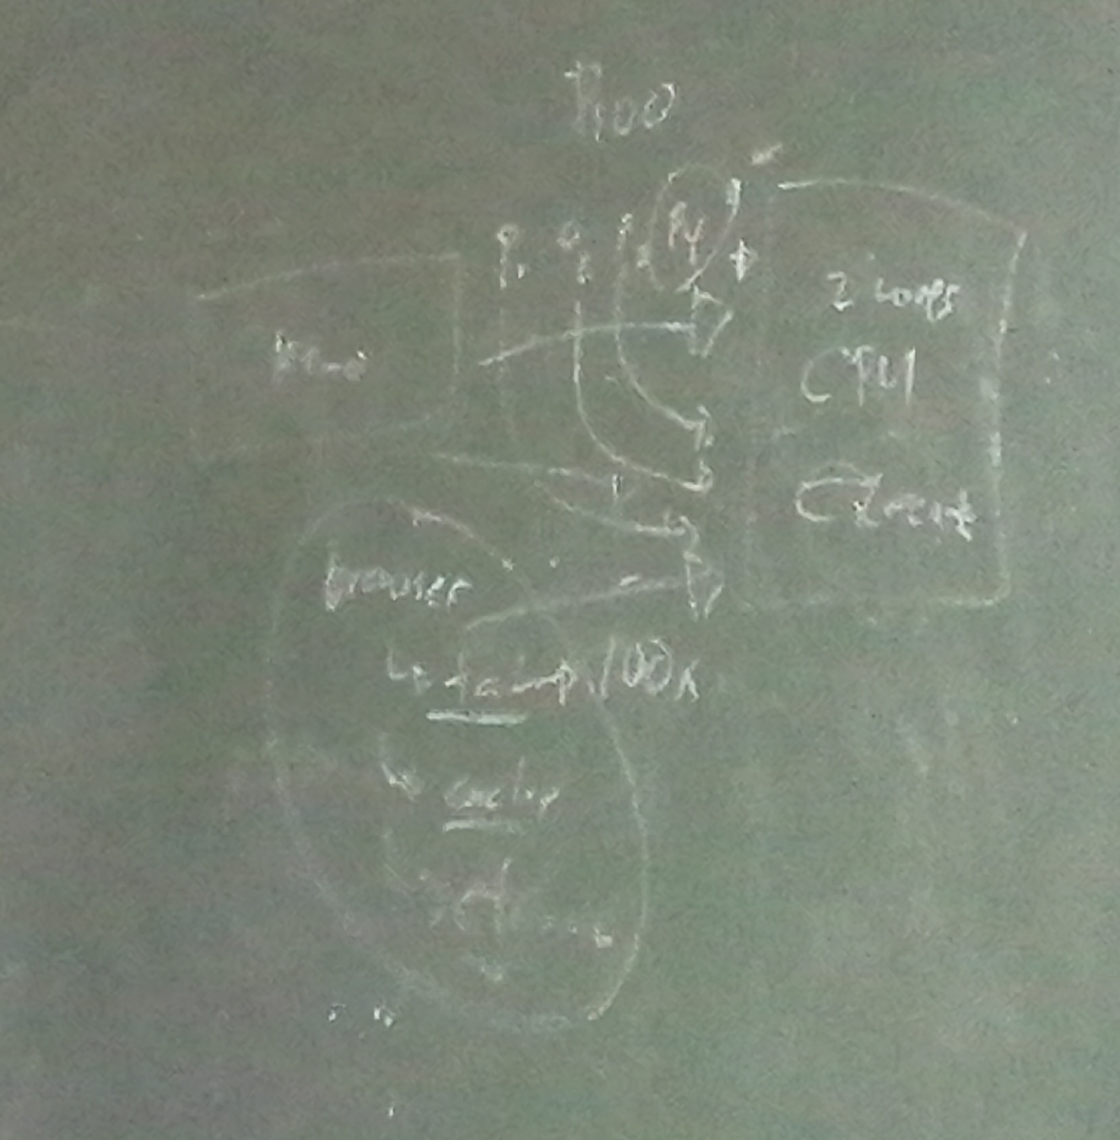

**What are the Primary memory’s Characteristics?**

* It is volatile memory.
* This memory is made of semiconductors technology
* Data is automatically deleted in the event of power failure.
* The processing speed is faster than secondary memory.
* This is the main working memory of the computer.
* 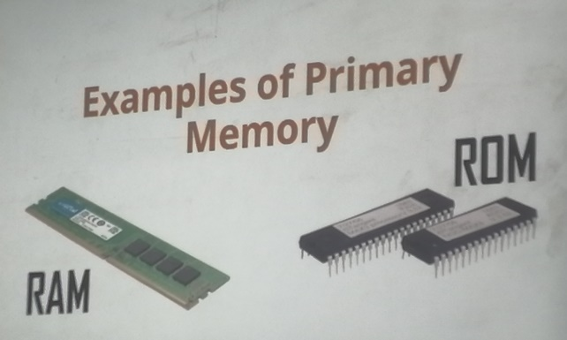A computer is not able to process without primary memory.

**Examples of Primary Memory**

* RAM
* ROM

**Power outage**

**What Is a Power Outage And A Power Surge?**

The scenario (lights flickering and then electricity going out) shows 3 main types of electricity anomalies:

The most obvious one is the power outage, also known as a blackout. A blackout occurs when the power is completely cut off. It happens for several reasons, including power station disruptions, damaged electrical lines, load-shedding, or self-inflicted damage – such as short-circuiting.

Lights flickering 2 possible reasons:

* wasn’t enough power available, causing a brownout
* A power surge occurs when there is an excessive amount of electricity comes from the socket source.

**How Do Power Outages or Power Surges Damage Your PC Components?**

There’s a reason our PCs have the shutdown option. They are designed to go through a series of processes before turning off. Therefore, a direct power outage or a power surge can be damaging in some circumstances, and in others, they will leave your system unscathed.

1. **Effect On PSU – The Self Sacrificial Heroes**

* In a situation where your PC faces an electrical anomaly, your PSU will offer the first line of defense. It will cover the unit and cut off the power supply to prevent damage.
* In the worst-case scenario, you’ll hear a loud band, and the PSU will self-destruct first, preventing damage from spreading to the rest of the system. This also happens when a [PSU lifespan](https://digitalworld839.com/how-long-do-power-supply-unit-last/) is nearing the end.
* If your computer won’t turn on after the PSU has caused a power outage, there is still hope. You can remove the power supply’s “dirty power” by leaving the system off for several hours (or a few days, to be sure). Meanwhile, you may test another PSU to ensure your PC is safe.

**Note** – There is one condition that must be met in order for the PSU to fulfill its potential as a savior. A good PSU from reputable manufacturers should be used. That is why installing cheaper power supply units, either [modular or non modular](https://digitalworld839.com/what-is-modular-and-non-modular-power-supply/) is never suggested.

1. **Effect on System Files**

* This is probably the nastiest effect of a sudden shutdown. Although it doesn’t cause hardware damage, so you don’t have to worry about replacement costs, it can cost you in terms of hours. And if it were billable hours, well, then it does cost you moneywise.

**For example**, suppose the power goes out during normal usage. In that case, you will most likely be greeted with the familiar disk check screen when you power on or [restart the PC](https://digitalworld839.com/how-often-should-you-restart-your-computer/), which is good.

1. **Effects on Storage Devices**

**Hard Disk Drives (HDD)**

HDDs suffer from sudden power outages and face a reduced life expectancy. The reason is that a sudden power cut brings the spinning disc to an abrupt and uncontrolled stop. Furthermore, the reading and writing head (which hovers over the spinning platters) has to quickly snap back into place.

* This snapping makes it susceptible to a “head crash,” which occurs when the head touches the platter surface, scrapping the area. The scrapped part can no longer record data, leading to crashes and slowdowns, eventually declining the HDD durability.

**Solid State Drives (SSD)**

* The result of power outages on SSDs is difficult to generalize. It might be affected or not. As compared to HDDs, older SSDs were much more vulnerable, and the impact ranged from data corruption to system failure.
* Fortunately, manufacturers have realized this issue and introduced a new safety feature called PLP (Power Loss Protection) Mechanism.
* PLP protects the data in the buffer from complete loss, as SSD does not have enough time to complete its tasks in case of unexpected shutdowns. This is accomplished with the help of capacitors on the SSDs that provide just enough time for the data to be flushed to long storage.
* However, SSDs have a limited life span. When they reach the end of their useful lives, SSDs are reset to zero regarding data loss or corruption. As a result, an outage may or may not cause SSDs to deteriorate.

**Primary Memory – RAM**

* RAMs aren’t affected due to power outages or surges. It is because multiple components will be affected before the RAM gets its turn. First, the PSU will die, then the motherboard (that too in some infrequent instances), and then the [primary memory – RAM](https://digitalworld839.com/what-is-primary-memory-of-computer-examples/).
* If [RAMs memory life](https://digitalworld839.com/how-long-does-a-ram-last/) damages, they usually include a lifetime manufacturer’s warranty. So, you can just claim its warranty and get a replacement.

**What Are the Symptoms of a Computer Power Surge?**

* Your PC isn’t turning on,
* You are facing trouble while booting up your system (stuck in a boot loop and reboots spontaneously),
* The fans are making a strange noise or are spinning very fast,
* PC is suspiciously overheating,
* You get electrical shocks when you touch the computer case,
* The PSU is failing and isn’t working at all.

The surge protectors limit the voltage beyond a set limit. And if the voltage exceeds the capacity, they burn themselves out, breaking the circuit between the wall socket and the PC.

Why You Should Get A UPS?

Surge protectors do protect your PC in case of power surges, but they don’t do much in a sudden shutdown. This is where UPS can help and is always recommended with a PC.

The UPS isn’t meant to keep your PC on the entire duration of a power outage, but they serve several important purposes. They supply battery backup for a few crucial minutes for you to save your work and safely shut down the system.

In addition, it serves as a two-in-one device by also acting as a surge protector. The UPS’ list of functions does not end there. It also serves the purpose of supplying clean and evened-out power, so you don’t face the small (unhealthy) drops in power when you turn on the AC.

The best part? The UPSs are totally worth it since they are going to be protecting a system that is worth 5x, maybe even 10 times their cost.

Power outages and power surges both are harmful to your computer. However, it is the power surges you need to really worry about.

They can cause problems ranging from a suspicious behavior of your computer to a complete loss of a component. Likewise, a power outage can cause nasty problems such as loss of data or data corruption, setting you back on hours of work. In some cases, a reinstall of windows might also be required.

Modern hardware and software, thankfully, are built with some concern for power outages and voltage spikes in mind. Repeated exposure, however, will undoubtedly damage in some form.

Because of this, it is always recommended to have a computer UPS or, at the very least, a surge protector. They are less expensive than you may think, especially considering the crucial purpose they serve.

It’s possible that an electrical problem will leave your PC unharmed. The risk of pushing your luck, however, is not worth it. Specifically when considering there is some damage in the long-term.